Part 1 — Hands-On Practice (Approx. 70 min)
A. Initialize and Configure (10 min)
mk dir day1_day2_practice
cd day1_day2_practice
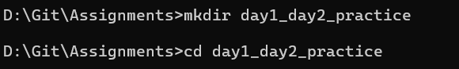
git init

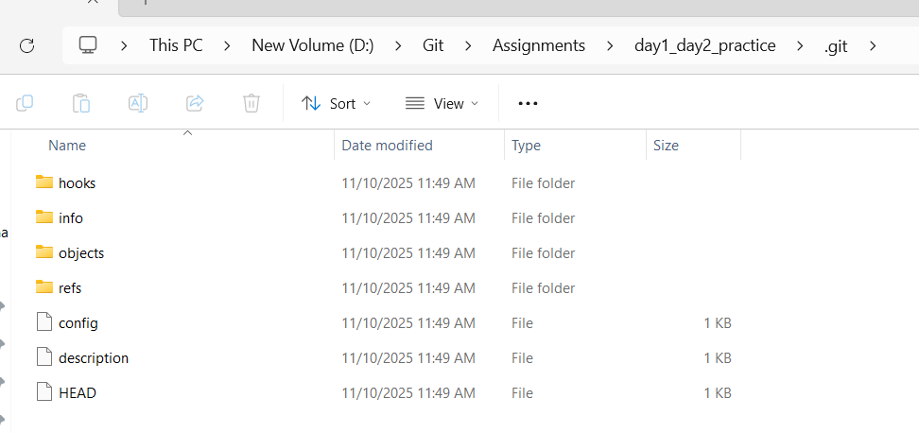
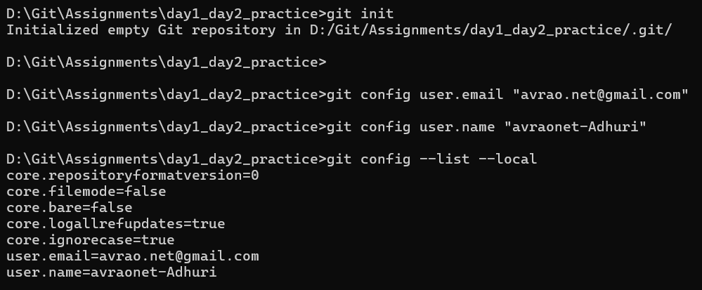
B. File Lifecycle (25 min)
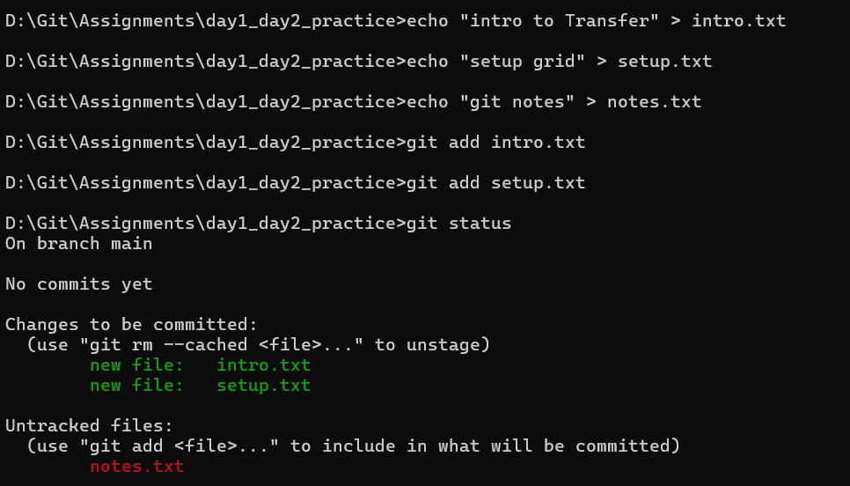
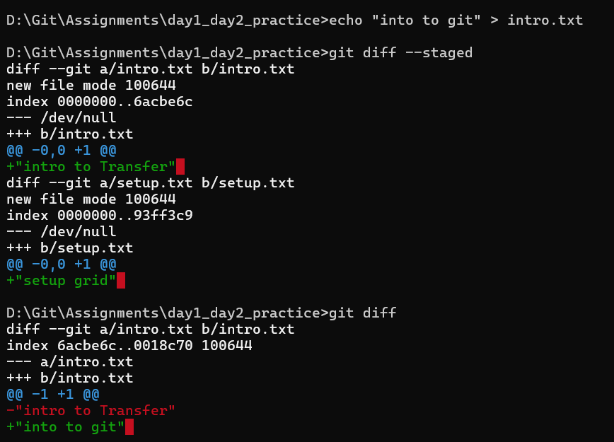
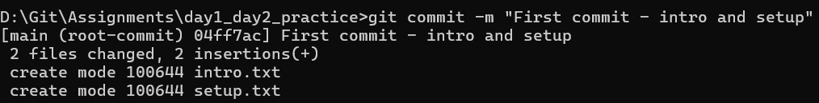
Q : Explain why the second edit to intro.txt didn’t go into the commit.
Ans: The second edit to a file didn't go into the commit because you can only amend the most recent commit. If you want to modify an earlier commit, you need to use the git commit --amend command, which allows you to add changes to the last commit. This means that any changes to files after the last commit will not be included in the commit history unless you use the amend option.

C. Inspect Internals (25 min)
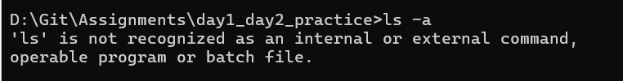
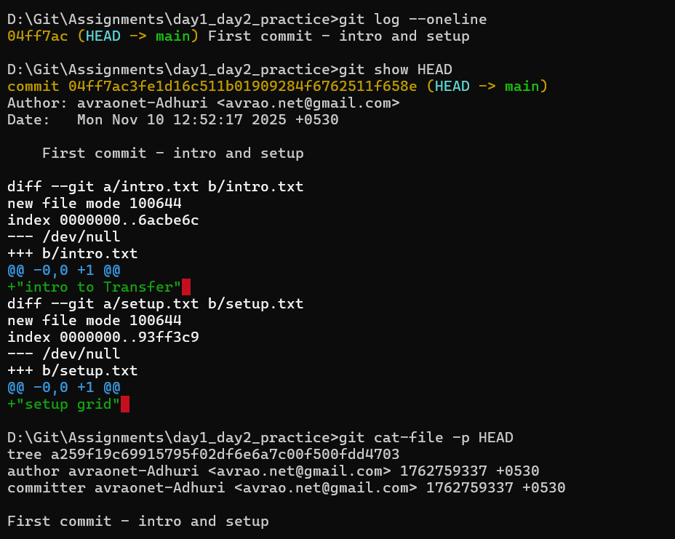
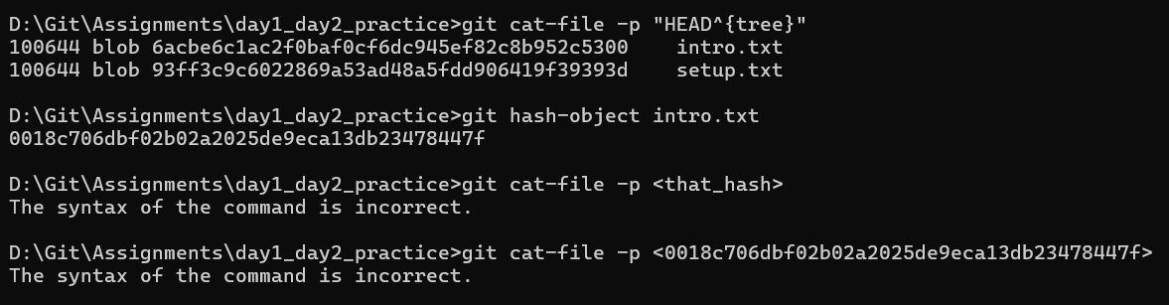
Part 2 — Conceptual Quiz (Approx. 40 min)
Answer briefly (3–4 sentences each, simple English):

1.What happens inside Git when you run git add file.txt?
Ans: Git takes the current version of file.txt and adds it to the staging area so it’s ready for the next commit.

2.Why do we say a commit is a snapshot, not a diff?
Ans: Because Git saves the entire state of all tracked files at that moment, not just the changes.

3.What is stored inside the .git folder?
Ans: It contains all Git metadata: commits, branches, tags, configuration, and object database.

4.What does HEAD point to, and how is it updated?
Ans: HEAD points to the current branch’s latest commit and updates when you commit or switch branches.

5.What’s the difference between the Working Directory and the Staging Area?
Ans: The working directory has your actual files; the staging area holds the versions you plan to commit.

6.What happens if you change a file after staging it?
Ans: The new changes stay in the working directory and won’t be committed unless you stage them again.

7.Why doesn’t Git store whole files for every commit?
Ans: To save space, Git stores files as objects and reuses unchanged data using hashes.

8.What is version control, and how does Git make it easier?
Ans: Version control tracks changes over time; Git makes it easy by allowing branching, merging, and history tracking.

9.What are tracked vs untracked files?
Ans: Tracked files are under Git’s control; untracked files are new and not yet added to Git.

10.Write the complete flow of commands from creating a repo to committing your first file:
Ans:
mkdir day1_day2_practice
cd day1_day2_practice
git init
git config user.email avrao.net@gmail.com
git config user.name "avraonet-Adhuri"
git config --list –local
echo "intro to Transfer" > intro.txt
echo "setup grid" > setup.txt
echo "git notes" > notes.txt
git add intro.txt
git add setup.txt
git status

